Ideation Phase
Empathize & Discover
Date | 28 September 2026
Team ID | 6ab221d587602313e82c60c9
Project Name | Import data using transform maps (spreadsheet)
Maximum Marks | 4 Marks
Empathy Map Canvas:
An empathy map is a simple, easy to digest visual that captures knowledge about a user's behaviours and attitudes.
It is a useful tool to helps teams better understand their users. Creating an effective solution requires understanding the true problem and the person who is experiencing it. The exercise of creating the map helps participants consider things from the user's perspective along with his or her goals and challenges.
Example:
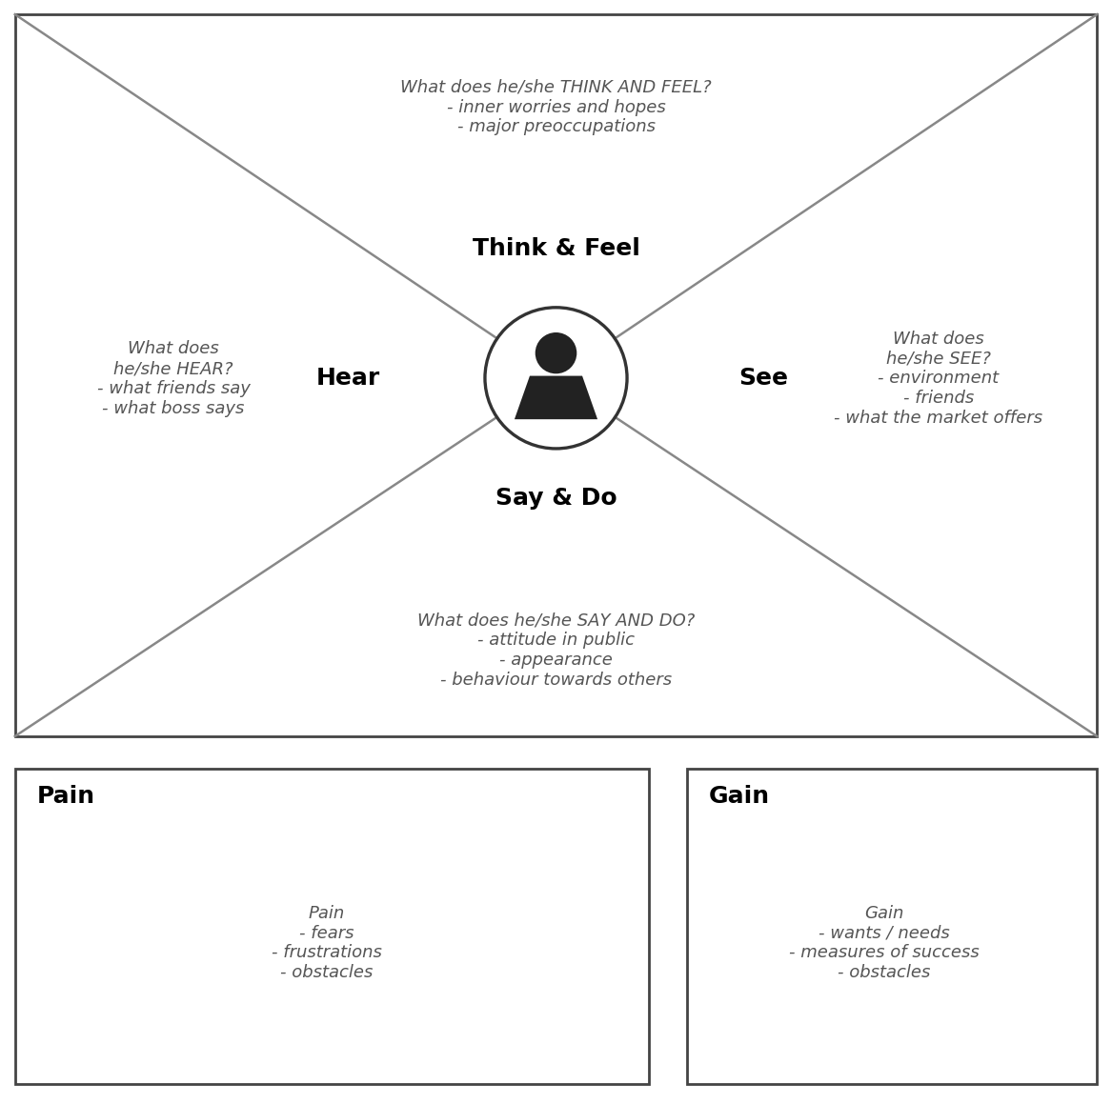

Example: Import data using transform maps (spreadsheet)
User: a system administrator who needs to import spreadsheet (Excel/CSV) data into a table.


